# SOFTWARE REQUIREMENTS SPECIFITION FOR

# ONLINE MOVIE TICKET BOKING SYSTEM

**TABLE OF CONTENTS**

1. Abstract
2. Introduction
   1. Objective
   2. Scope
   3. Definition
   4. Overview
3. SDLC Models
   1. Phases of SDLC
4. Functional Requirements
5. Non- Functional Requirements
6. UML Diagram
7. Class Diagram
8. Sequence Diagram

# 1.Abstract

Many people choose to conduct online because of the convenience. For example, when a person book a ticket through Movie Theater, he/she has to drive to the movie theater, find a parking place, and walk through the movie theater until he/she locates the theater. With the development of technologies, increasing digitalization, and increasing social networking, information sharing on internet has become quite. As a result of that all the online system has become very popular in the last 6-10 years. According to the largest online purchase happened in Asia Pacific. Discussions and use of online system has become much more frequent than the offline one. Movie booking system is one such trending system now a day. It provides the user to online browse and book movie tickets. With the increase in technology there has been lots of advancement in online booking system. Users are now able to see the seating plan and they can also book refreshments online. Digitalization is one of the most amazing outcomes of technology . It has given easy accessibly of all the resources available. Wasting time in the queues of movie theatre has been ruled out due to online system. Also, reviews can be easily read online so that user can get a clear-cut picture about the movie. Online payment has also increased E-Banking which is helpful for the sound development of countries economy. Movie ticket booking in web is the process by which customer can purchase their movie tickets directly using internet and pay through online banking. Online movie ticket booking system is measurable, cost effective and has very good user interface. This web based HTML,CSS and JS project provides the all working of cinema ticket booking system.

# 2.Introduction

## 2.1 Objective

The objectives of online booking are to have clear goals that drive the strategies and actions of purchases. Online booking , has transformed the way businesses operate in the digital age. As more and more consumers turn to online booking for their movies and services, online booking are becoming increasingly prevalent. However, simply having an online booking website is not enough to succeed in today’s competitive market. To be successful, online booking need to have clear objectives that drive their strategies and actions. To be a secure and preferable platform for online booking with a variety of options and requirements according to the clients. By achieving these goals, the Online Booking project will improve the satisfaction of customers.

**2.2 Purpose**

The purpose of this software requirement specification is to provide a documented model for the online movie ticket booking. This document provides a userfriendly online booking platform. The system includes two sides, one is the client side as well and another one is the seller side. The online booking system provides a platform for conducting sales of a wide variety of goods across the globe. It is implemented as an internet-based enterprise and has a vast number of movies from books, houseware, electronics, groceries, and much more. Sellers use this system to easily expand their service to a more global platform.

Nowadays online booking is consistently used because of upgrading the

movies with multiple varieties and brands. It will provide that client need not worry about the movie,.As it follows the reliability.

### 2.3 Scope

One of the biggest impacts of the pandemic on the grocery industry has been the boom in online ordering. According to a report, the consumers’ booking habits shifted from monthly to weekly after the onset of the pandemic. This was mainly driven by the increase in essential booking during this period.

Owing to the high preference for online booking and the disruption caused by online grocers, we can expect a rising pressure on the brick-andmortar stores in the coming days.

### 2.4 Definition

Online booking is the process of researching and purchasing movies or services over the [Internet.](https://www.newworldencyclopedia.org/entry/Internet) The earliest online stores went into business in 1992, and online [retailing](https://www.newworldencyclopedia.org/entry/Retailing) took over a significant segment of the retail market during the first decade of the twenty-first century, as ownership of personal computers increased and established retailers began to offer their movies over the Internet.

**2.5 Overview**

Welcome to the Online Booking , our platform is not just a place to shop; it's an immersive experience designed to delight users at every click.

Our ultimate goal is to redefine the way people shop online.

### 3. SDLC Models

There are many different SDLC models in software engineering, and they vary according to many factors. Still, the sequence of software life cycle phases usually remains the same, with a few exceptions.

**3.1** **Phases of SDLC**

Let’s see what software life cycle phases there are and what should be done during each.

1. Requirements Gathering
2. Design
3. Implementation
4. Testing
5. Deployment and Maintainance

**4. Functional Requirements**

## Registration

If customer wants to buy the movie then he/she must be registered, unregistered user can not go to the booking book.

## Login

Customers logins to the system by entering valid user id and password for the booking

## Booking tickets

Changes to the book means the customer after login or registration can make order or cancel order of the ticket from the show

## Payment

In this system we are dealing the mode of payment by cash, we will

extend this to credit card, debit card etc.., in the future.

## Log out

After booking or viewing the website in the software the customer has to logout from the software.

**5.Non Functional Requirements**

## Performance

The system should respond to user actions within a defined timeframe, typically measured in milliseconds. The software should be able to scale up or down seamlessly to user traffic with out sacrificing performance.

## Availability

The system should be available for users to access and se whenever needed, aiming for high availability. The system to continue to operate properly in the event of failures, such as server crashes or network issues, minimizing downtime.

|  |  |
| --- | --- |
| *-Aspiresystems* | **Authentication and authorization**  Only authorized users should be able to access specific functionalities or date within the system, with robust authentication mechanisms  **User interface design**  The interface should be intuitive and user-friendly, making it easy for users to navigate, search for movies, and complete transactions.  **Accessibility**  The platform should be accessible to users with disabilities, adhering to accessibility standards such as Web content accessibility guidelines.                **UML DIAGRAM- Use Case Diagram**  https://bltsyfemon.us-04.visual-paradigm.com/rest/diagrams/projects/clipboard/1_hLdIrvGFYDwCBxLS?dummy=1SjIrvGDolh.QAGF |

### System flowchart Diagram

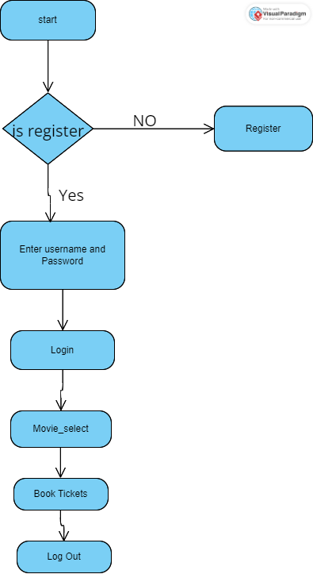

**Class diagram**

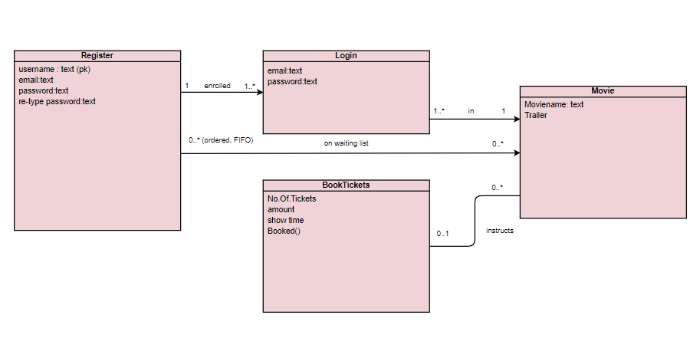

**SYSTEM ANALYSIS**

System analysis is the process of gathering and interpreting facts, diagnosing problems and using the information to recommend improvements on the system. System analysis is a problem-solving activity that requires intensive communication between the system users and system developers. System analysis or study is an important phase of any system development process. The system is viewed as a whole, the inputs are identified and the system is subjected to close study to identify the problem areas. The solutions are given as a proposal. The proposal is reviewed on user request and suitable changes are made. This loop ends as soon as the user is satisfied with the proposal. 1. Existing system The current system for shopping is to visit the shop manually and from the available product choose the item customer want and buying the item by payment of the price of the item. • User must go to shop and select products. • It is difficult to identify the required product. • Description of the product is limited. • It is a time-consuming process. • Not in reach of distant users. 2.. Proposed system In the proposed system customer need not go to the shop for buying the products. He can order the product he wish to buy through the application in his Smartphone. The shop owner will be admin of the system. Shop owner can appoint moderators who will help owner in managing the customers and product orders. The system also recommends a home delivery system for the purchased products. 4. Feasibility study Feasibility requirements are undertaken to have a view of understanding the features that are incorporated in terms of the requirements to design and implementation. The references of the feasibility study will be divided into multiple sections so that the understandability can be ARKA JAIN UNIVERSITY 05/04/2022 15 organized so for example if we have to design software the required investment and flow of cash has to be properly analysed in the same way technical associations are acquired to be discussed. • Technical feasibility. • Operational feasibility. • Economic feasibility. 5. Technical feasibility The customization that has to be operational when a particular identity or field is changed has to be replicated in real time which has to be properly designed and tested for the workability. All types of working references are provided in terms of the resources within the company premises. The integrated settings that are required for the accompanied sharing and alert system will also be associated properly and the vendor integrations will be tested for security provisions. The accessibility of the standards that are required will be properly define so as to acknowledge the formats of reports which has to be in-clubbed in different types of reporting sections that are incorporated. 6. Operational feasibility Apprehension of working is required to be properly planed as when the system will be provided to multiple users a proper support has to be provided as multiple integrated functionalities are provided. The applications that may arise has to be drafted it so that in the real time working it can be properly acknowledged as multiple Global finance will be incorporated to the system. A proper documentation will be provided with all variations of report and the standing in the customization options that are provided under the setting 7. Financial feasibility Financial return on investment calculation so will be done by the financial team with the help of multiple associated software that are available will be used. Considerations of the cash flow will be determined as the source of income has to be properly acknowledged ARKA JAIN UNIVERSITY 05/04/2022 16 SYSTEM REQUIREMENT SPECIFICATION FUNCTIONAL REQUIREMENTS USER 1. USER LOGIN Description of feature • This feature used by the user to login into system. A user must login with his user’s name and password to the system after registration. If they are invalid, the user not allowed to enter the system. Functional requirement • Username and password will be provided after user registration is confirmed. • Password should be hidden from others while typing it in the field 2. REGISTER NEW USER Description of feature • A new user will have to register in the system by providing essential details in order to view the movies in the system. The admin must accept a new user by unblocking him. Functional requirement • System must be able to verify and validate information. • The system must encrypt the password of the customer to provide security. 2. BOOK A MOVIE Description of feature • The user book available tickets while he is searching for one tickets or more tickets. After successful booing user gets message from admin “your Ticket has Successfully Booked” Functional requirement • System must ensure that, only a registered customer can books tickets ARKA JAIN UNIVERSITY 05/04/2022 17 ADMIN 1. MANAGE USER Description of feature • The administrator can add user, delete user, view user and block user. 2. MANAGE MOVIES SCHEDULE Description of feature • The administrator can manage Schedule and search for a Seat Availability. 3. MANAGE TICKETS Description of feature • The administrator can add Movies, delete Movie and view Movie